How to export a job/task from your TASKLINK to a txt file.

- Go to Task Manager.

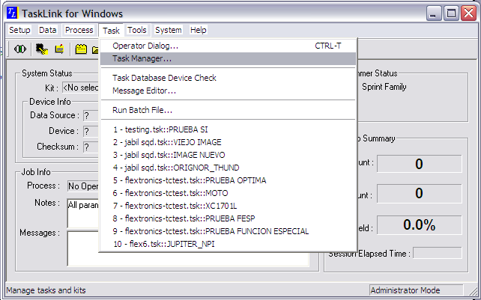

- From Task Manager window, Select your job/task that you wish to export, and click on the Export Button.
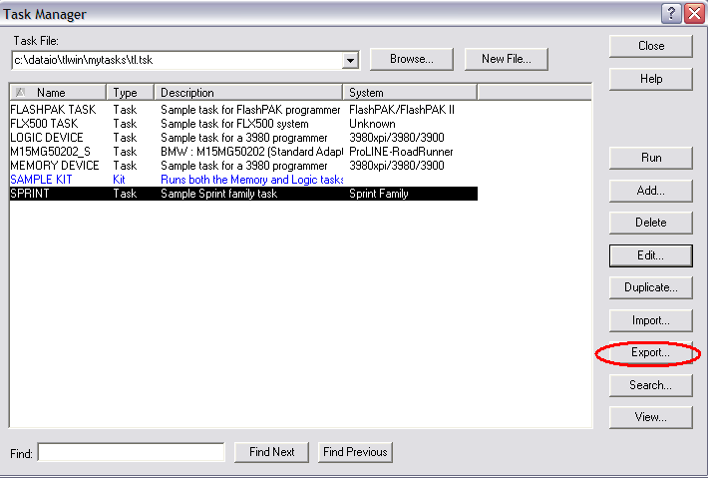

- Once you have clicked in the Export button, you can now assign any file name (short if possible) to your exported job, and you may also assign any directory path as you wish, wherever you want to save your exported file.

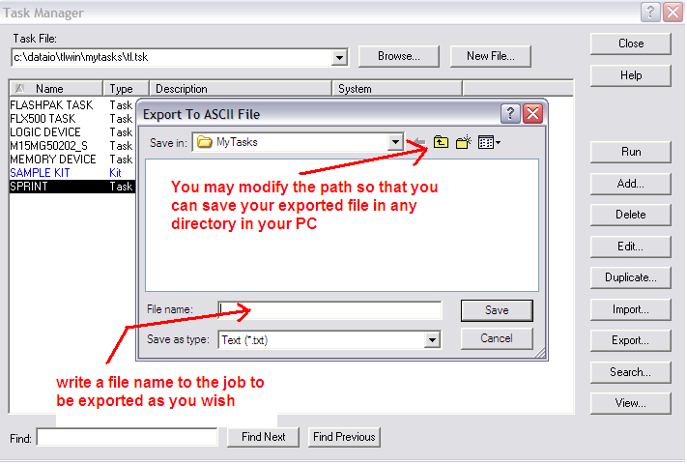

- Then you have completed the exportation of your job/task in txt mode.
You can now email it to us!

